QUERY_01 , 02 :-

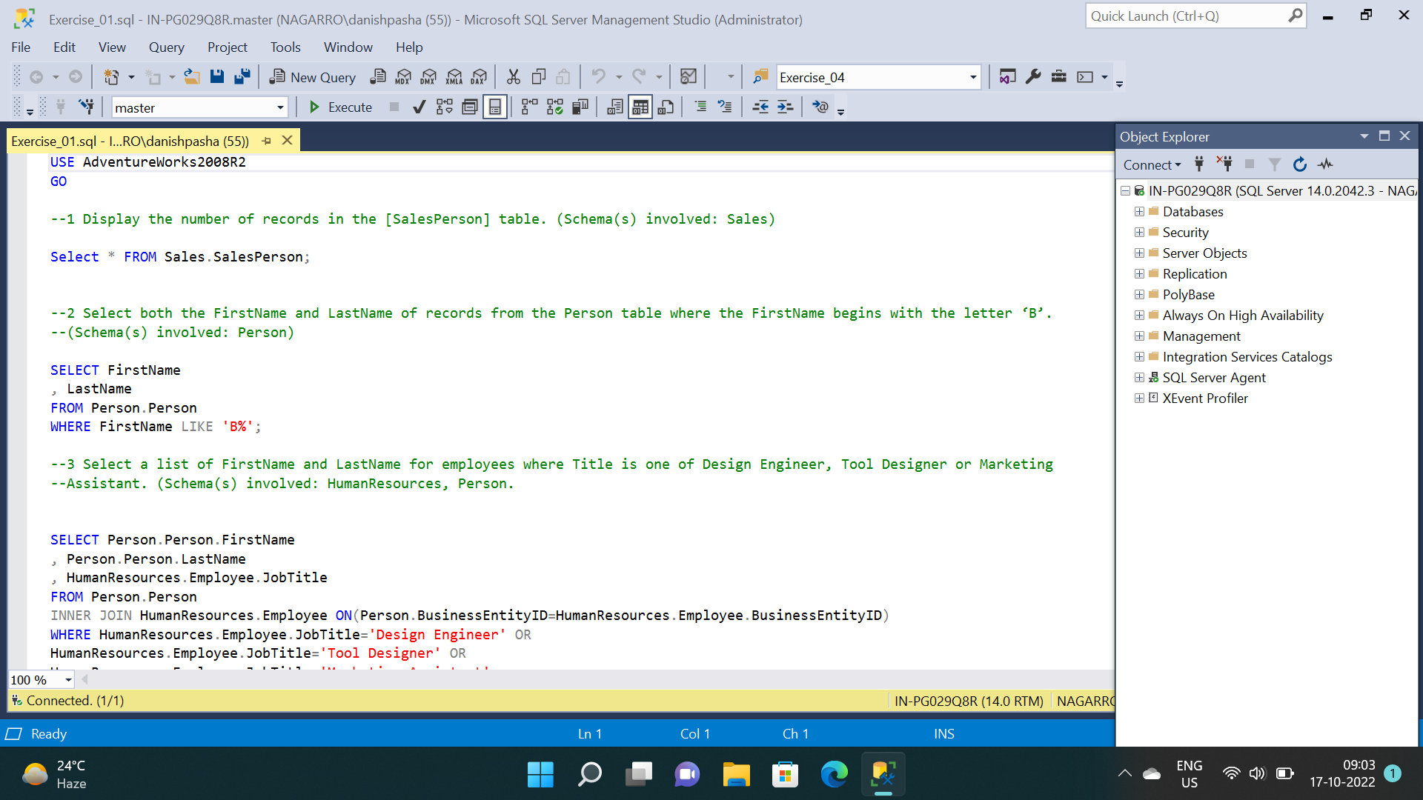

RESULT_01:-

RESULT_02:-

QUERY_03:-

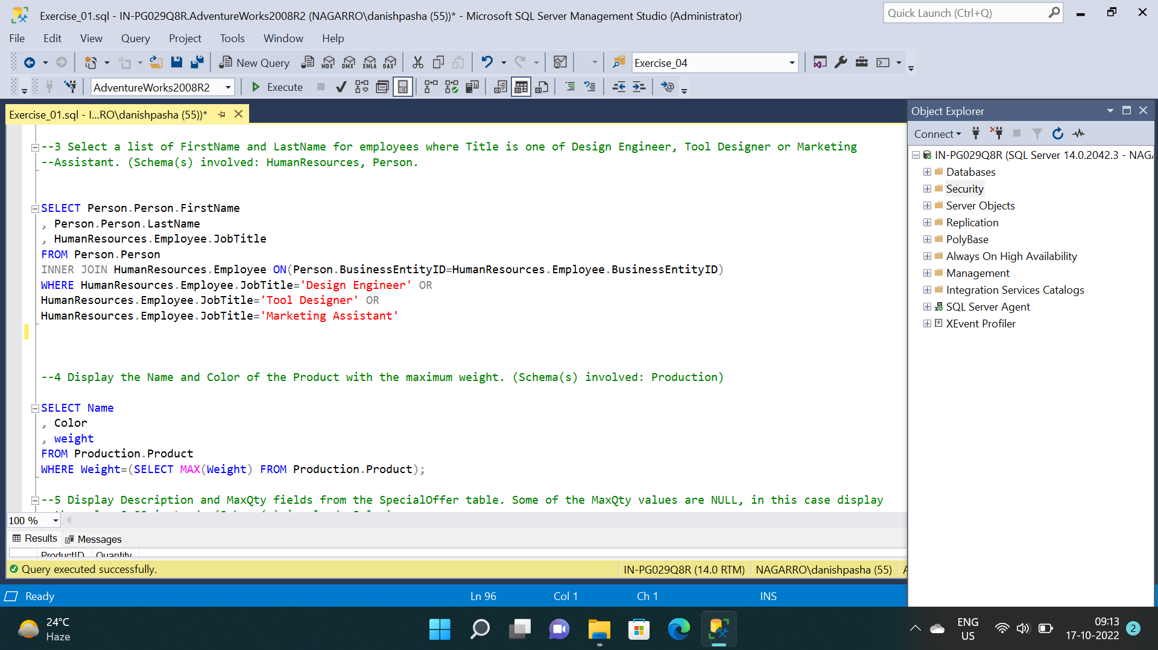

RESULT_03

QUERY_04, 05

RESULT_05

QUERY_06,07

RESULT_06:-

RESULT_07:-

QUERY_08

RESULT_08:-

QUERY_09 , 10 :-

RESULT_09 :-

RESULT_10:-

